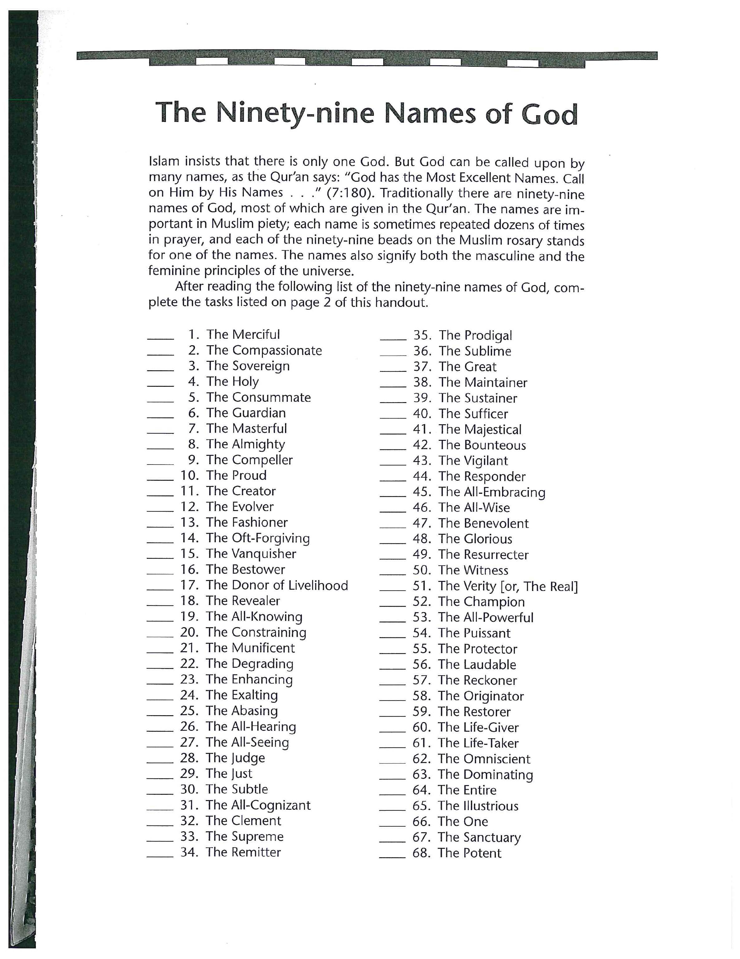
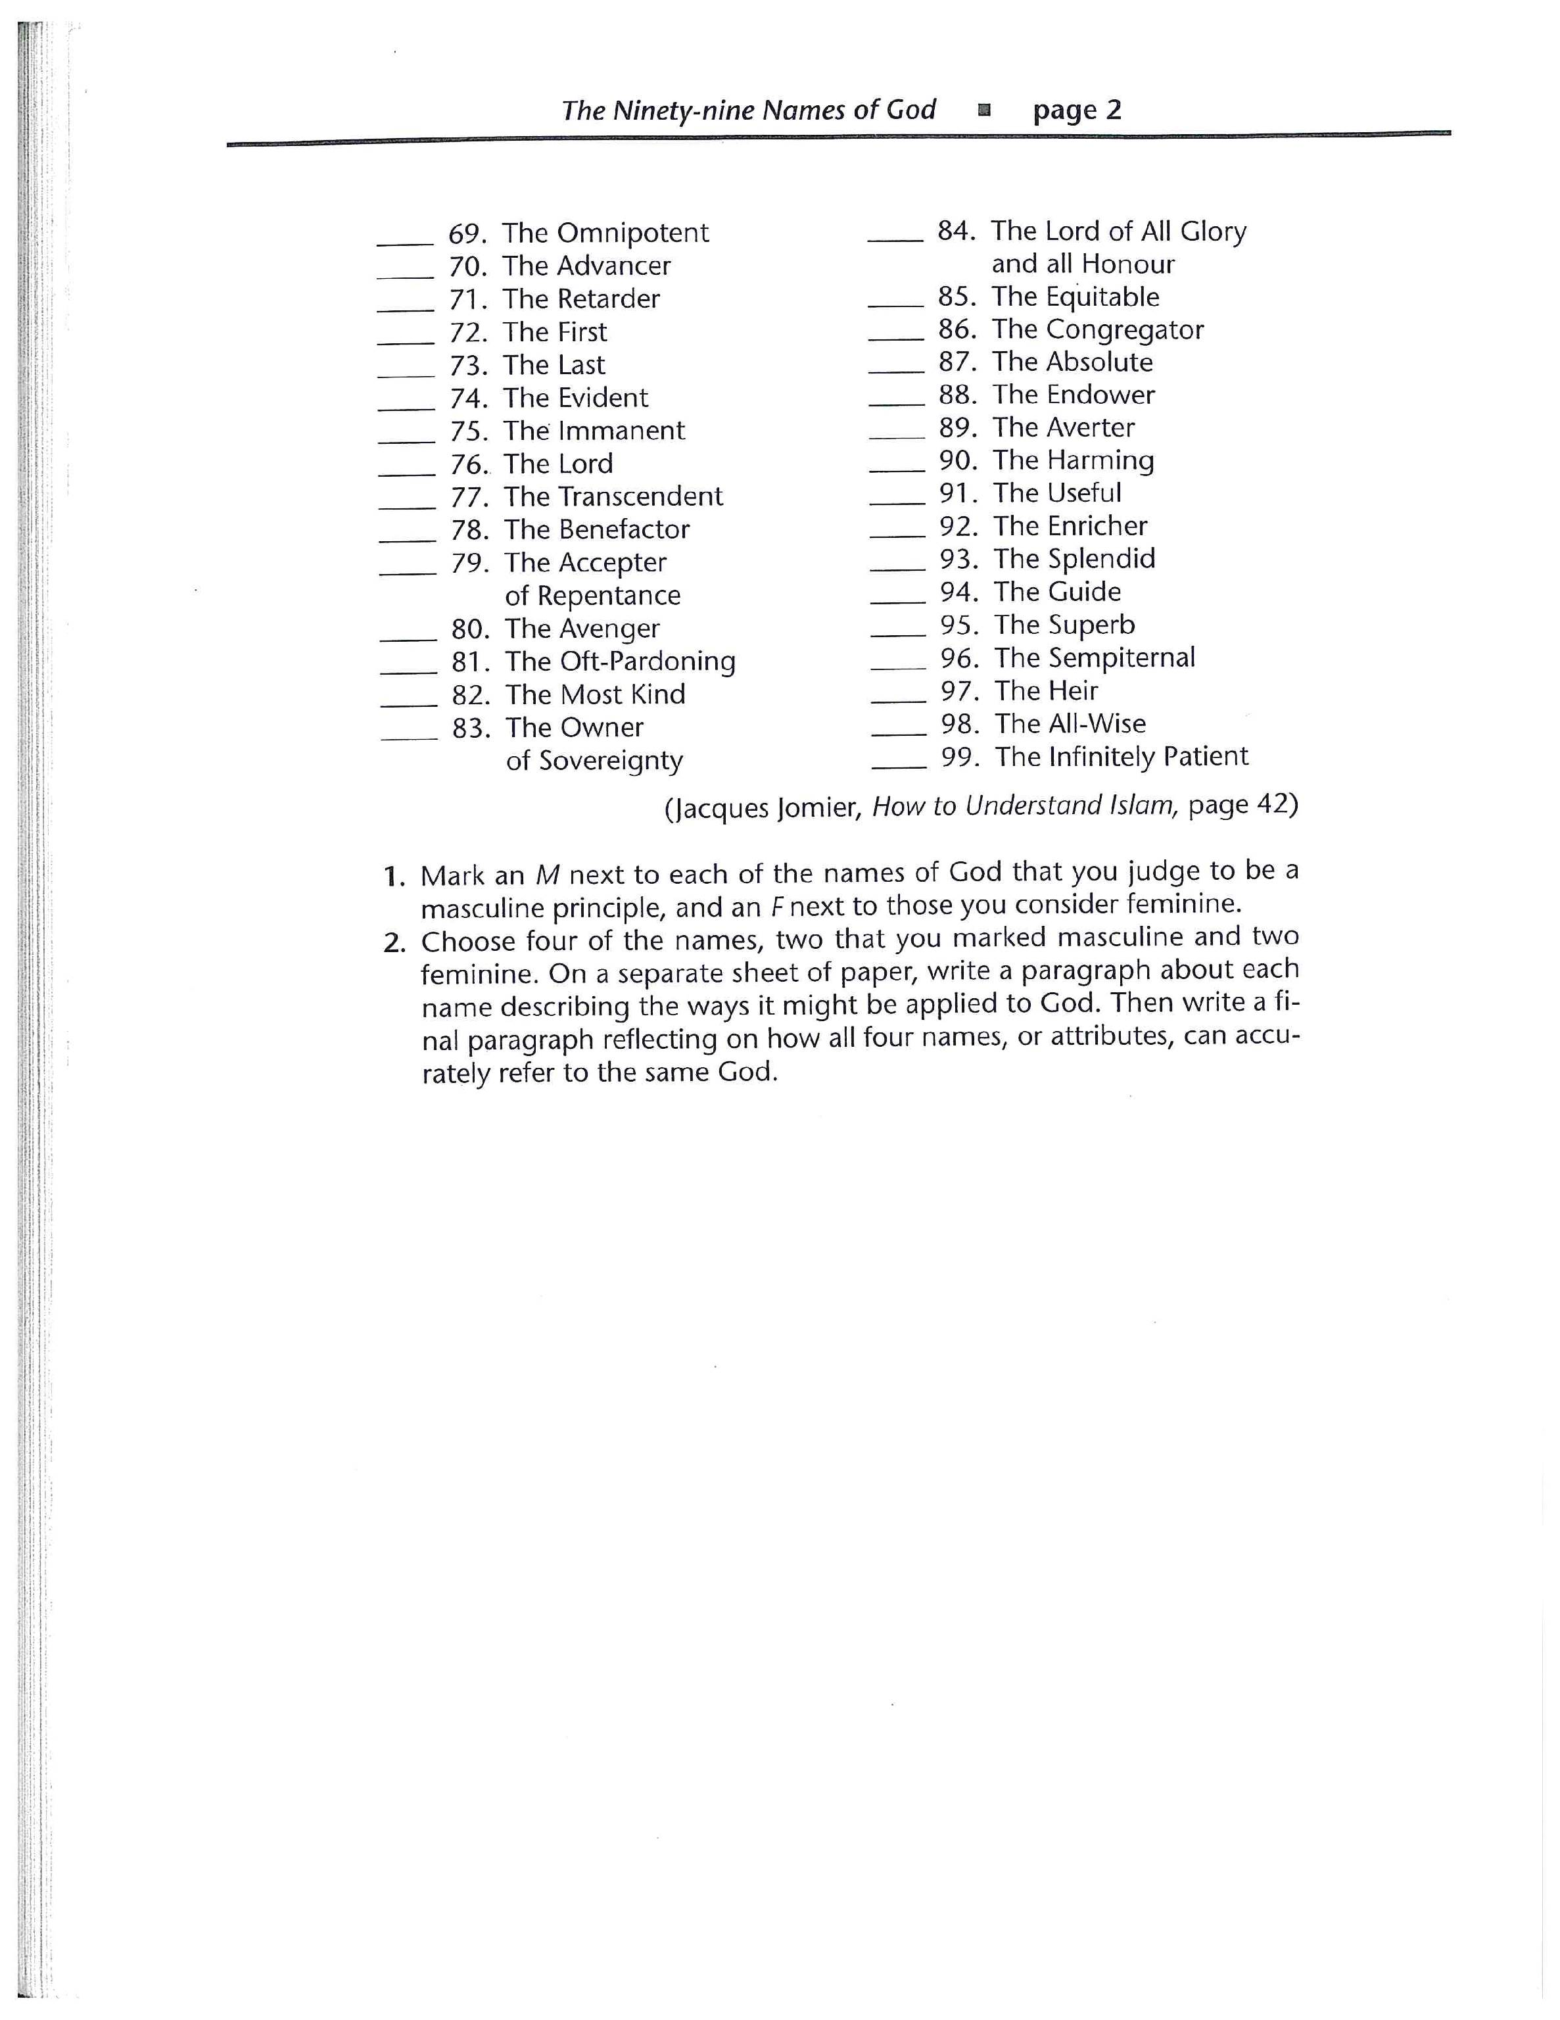
99 Names of God

Abasing - to reduce or lower, as in rank, office, reputation, or estimation; humble; degrade
Averter - to ward off; prevent: to avert evil
Benevolent - desiring to help others; charitable
Bestower - to present (a gift) or confer (an award or honour)
Bounteous - giving or disposed to give freely; generous; liberal.
Clement - mild or merciful in disposition or character
Cognizance - awareness, realization, or knowledge; notice
Compeller - to have a powerful and irresistible effect, influence
Constrainer - to force, compel, or oblige
Consummate – perfection, supremely skilled
Exalting - to raise in rank, honor, power, character, quality, etc
Illustrious - highly distinguished; renowned; famous
Immanemt - transcending the universe, time, etc.
Laudable - deserving praise; praiseworthy; commendable
Munificent - extremely liberal in giving; very generous
Omnipotent - almighty or infinite in power
Omniscient - having complete or unlimited knowledge
Prodigal - giving or yielding profusely; lavish
Puissant - powerful; mighty; potent.
Remitter - restoration, as to a former right or condition
Sempiternal - everlasting; eternal
Sovereign - having supreme rank, power, or authority.
Sublime - supreme or outstanding
Subtle - difficult to perceive or understand
Sufficer - to be adequate or satisfactory for (something)
Vanquisher - to conquer or subdue by superior force
Vigilant - keenly watchful to detect danger; wary: a vigilant sentry.

