K/U /15 T/I /15 COM /15 APP /15 NAME:

Beatitude Project

Part 1

Directions: On a SEPARATE piece of paper rewrite each of the Beatitudes in your own words. Make sure you use words that you understand and can explain. The important thing here is that you show me you know what each of The Beatitudes mean. (K/U 15 marks)

Blessed are the poor in spirit, for theirs is the kingdom of heaven.

Blessed are those who mourn, for they shall be comforted.

Blessed are the meek, for they shall inherit the earth.

Blessed are those who hunger and thirst for righteousness, for they shall be satisfied.

Blessed are the merciful, for they shall obtain mercy.

Blessed are the pure in heart, for they shall see God.

Blessed are the peacemakers, for they shall be called sons of God.

Blessed are those who are persecuted for righteousness' sake, for theirs is the kingdom of heaven.

Part 2

Directions: For each of the Beatitudes you are to create a symbol that represents that Beatitude to you. For example if you were to look at the Beatitude, Blessed are the merciful, for they shall obtain mercy, you might create a symbol of two people hugging as this represents forgiveness to you. (T/I 15 Marks, COM 15 Marks)

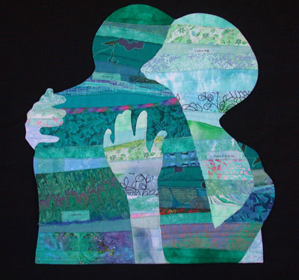

Part 3

Directions: On a Separate piece of paper design a Beatitudes Poster. It could include all the Beatitudes or just your favourite one. (APP 15 Marks)

