K/U /10 T/I /10 APP /10 COM /10 NAME:

Cast Away Assignment

- Explain using specific examples from the movie how we need other people in our lives.

- If you were stranded on an Island what three things would you want to have with you, excluding other people or pets. Remember to support your answers with specific examples from the movie.

- Using both Chuck and Kelly as examples explain what stage of Kohlberg’s moral reasoning they are at. Support your answers with specific examples from the movie.

- How do you think Chucks life changes after he returns from the Island? Support your answers with specific examples from the movie.

- Using both Chuck and Kelly as examples, pick a part of the movie and show how they follow their conscience. Support your answers with specific examples from the movie.

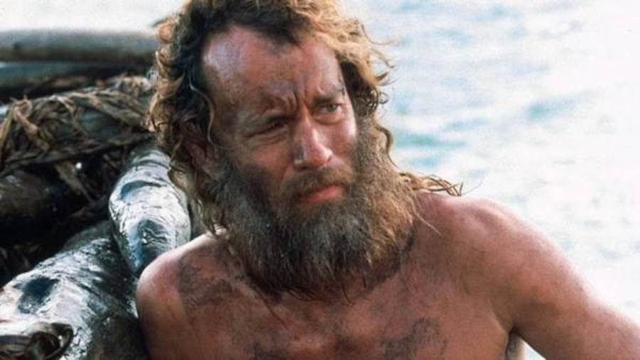 Tom Hanks – CHUCK

Helen Hunt - KELLY

