K /10 T /10 C /10 A /10 NAME:

Exodus: Gods and Kings Assignment

Make sure to support your answers with specific examples form the movie.

- What does Moses learn about his past from Nun? (K /5 Marks)

- What does Ramses do when he finds out the information? (K/5 Marks)

- Moses ends up getting married. Why do you think he does this? (T/5 Marks)

- What makes Moses leave his family? (T/5 Marks)

- What does Moses ask of Ramses and what does Ramses do? (C/5 Marks)

- In the end it is the Plague’s of God that Change Ramses mind. What are the different Plagues? (C/5 Marks)

- How do the Hebrews escape in the end and what does God give to them? (A/10 Marks)

Cast of Exodus: Gods and Kings

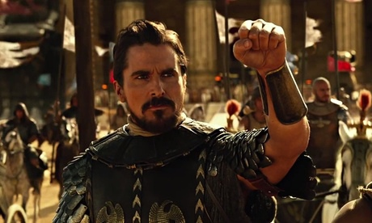 Christian Bale – Moses

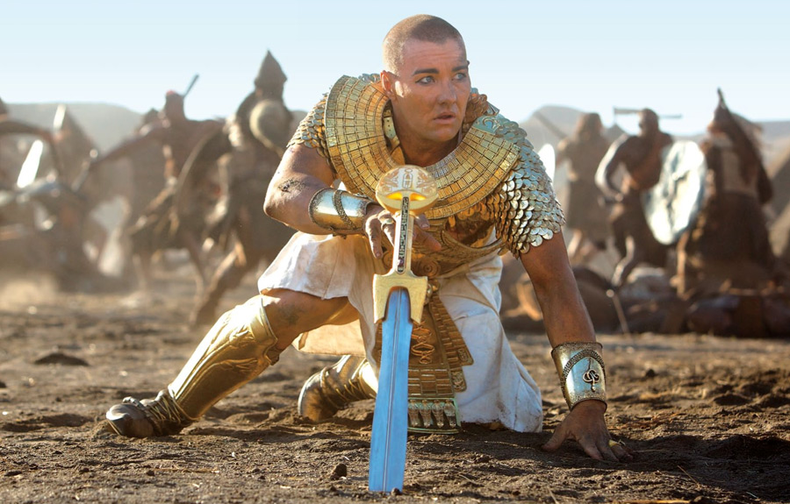 Joel Edgerton – Ramses

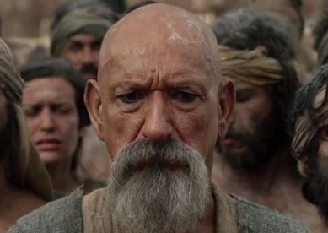 Ben Kingsley – Nun

Maria Valverde – Zipporah

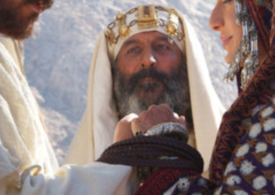 Kevork Malikyan – Jethro

Aaron Paul – Joshua

Andrew Talbot – Aaron

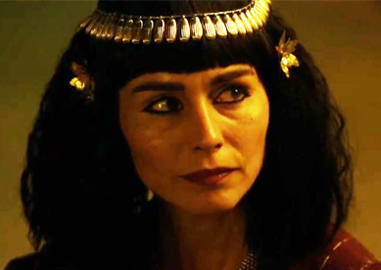 Tara Fitzgerald – Miriam

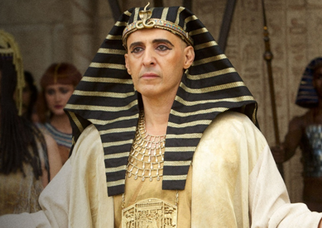 John Turturro – Seti

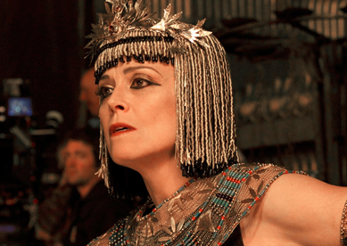 Sigourney Weaver - Tuya

