K /15 T /15 COM /15 APP /15 NAME:

John Q Assignment

- List 3 commandments and 3 beatitudes that are followed or broken in the movie. Make sure to give specific accounts from the movie to describe when each one occurred. (K /15 marks)

- Was John Q. justified? Are we justified in breaking the law to claim our rights as individuals? Give me an example from real life to support your answer. (T /15 Marks)

- Pick three (3) different characters from the movie and explain what stage of Kohlberg’s Theory of Moral Development they are at. Use specific examples from the movie in your answer. (Com /15 marks)

- In this movie, the media are responsible for helping generate public support for John Q. In reality, do you think media coverage can help or put the hostages at greater risk? Does media coverage encourage or discourage people to commit crimes? (APP /15 Marks)

Cast listed on back of page

John Q Cast

Denzel Washington as John Archibald
Kimberly Elise as Denise Archibald
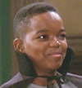 Daniel E. Smith as Michael 'Mike' Archibald
James Woods as Dr. Raymond Turner
Anne Heche as Rebecca Payne
Robert Duvall as Lt. Frank Grimes
Ray Liotta as Chief Gus Monroe
Shawn Hatosy as Mitch Quigley
Heather Wahlquist as Julie Bird
David Thornton as Jimmy Palumbo
Laura Harring as Gina Palumbo
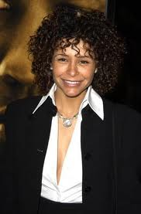 Troy Beyer as Miriam Smith
Kevin Connolly as Steve Maguire
Troy Winbush as Steve Smith
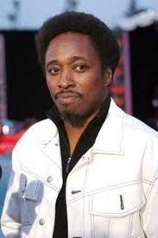 Eddie Griffin as Lester Matthews
Larissa Laskin as Dr. Ellen Klein
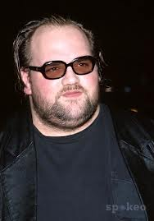 Ethan Suplee as Guard Max Conlin

